H.T No
Regulations:
A18

Sreenidhi Institute of Science and Technology
(An Autonomous Institution)
Code No: 7BC03 Date: 09-Oct-2020 (FN)

B.Tech I-Year I-Semester External Examination, October - 2020 (Supplementary)
ENGINEERING MECHANICS (ME)

Time: 2 Hours Max.Marks:70

Note: a) No additional answer sheets will be provided.
b) All sub-parts of a question must be answered at one place only, otherwise it will not be valued.
c) Missing data can be assumed suitably.

ANSWER ANY 5 OUT OF 8 QUESTIONS. EACH QUESTION CARRIES 14 MARKS.

1. | a) | A system of connected flexible cables as shown in Fig.1 is supporting two vertical forces 200 N and 250 N at points B and D. Determine the forces in various segments of the cable.  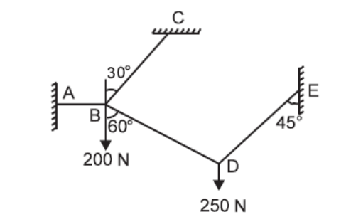  Fig.1 | [7M]
 | b) | Two smooth spheres each of radius 100 mm and weight 100 N, rest in a horizontal channel having vertical walls, the distance between which is 360 mm. Find the reactions at the points  of contacts A, B, C and D shown in Fig. 2  . 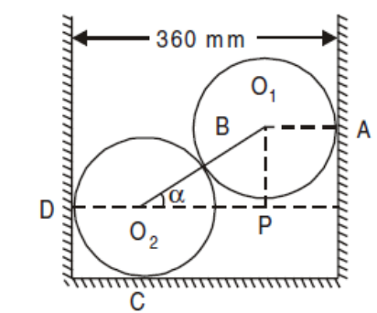  Fig. 2 | [7M]
2. | a) | Analyze the truss shown in Fig. 3. All the members are of 3 m length.  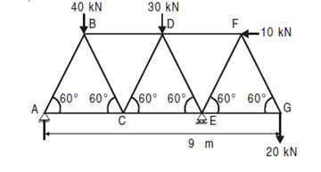  Fig. 3 | [7M]
 | b) | A simply supported beam AB of span 5 m is carrying a point load of 2 kN at a distance of 2m from A. Determine the Reactions at the supports by using the principle of virtual work. | [7M]
3. | a) | Determine the centroid of the shaded area shown in the Fig 4 below  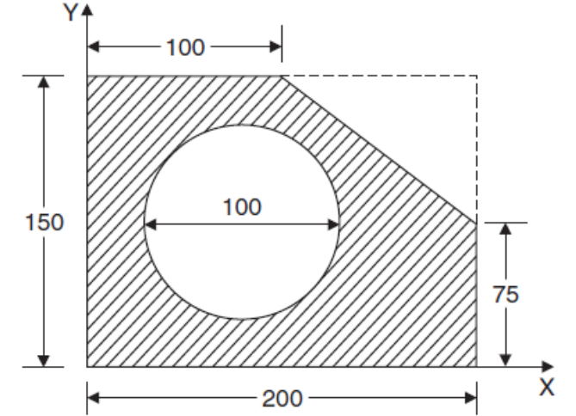  Fig 4 | [7M]
 | b) | A pull of 180 N applied upward at 30° to a rough horizontal plane was required to just move a body resting on the plane while a push of 220 N applied along the same line of action was required to just move the same body downwards. Determine the weight of the body and the coefficient of friction. | [7M]
4. | a) | State and explain theorems of Pappus-Guldinus. | [4M]
 | b) | Determine the moment of inertia of the built-up section in Fig.5 below  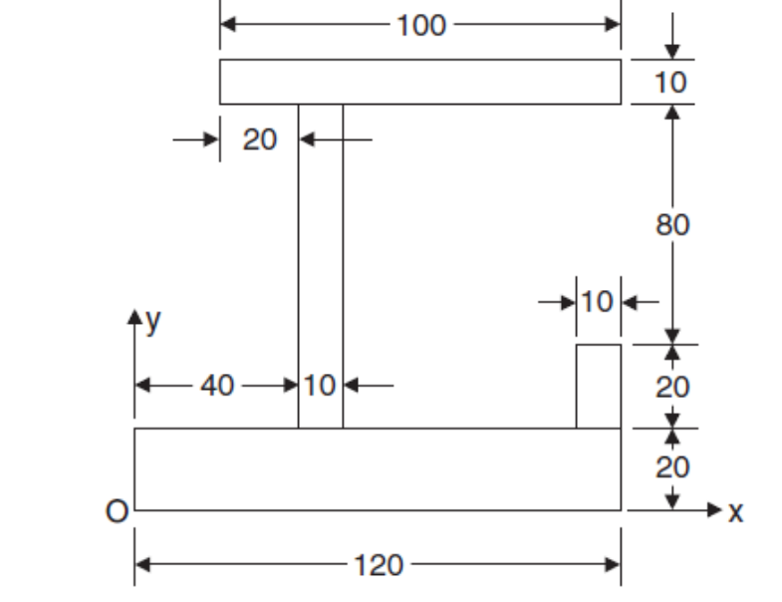  Fig.5 | [10M]
5. | a) | A stone is thrown vertically upwards at the speed of 19.6ms⁻¹ from a tower of 24.5m. determine  - The time required to reach the ground  - Maximum rise of the stone from the ground  - Velocity with which the stone hits the ground | [7M]
 | b) | A flywheel, which accelerates at uniform velocity, is observed to have made 100 revolutions to increase its velocity from 120 rpm to 160 rpm. If the flywheel originally started from rest, Determine  - The value of acceleration  - Time taken to increase the velocity from 120 rpm to 160 rpm and  (iii) Revolution made in reaching a velocity of 160 rpm, starting from rest. | [7M]
6. | a) | Two blocks are connected by inextensible wires as shown in  Fig. 6 Find by how much distance block 400 N will move in increasing its velocity to 5m/s from 2 m/s. Assume pulleys are frictionless and weightless.  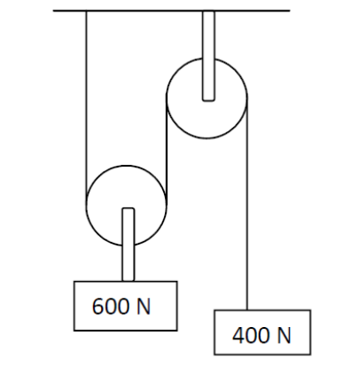  Fig. 6. | [7M]
 | b) | A bullet weighs 0.5N and moving with the velocity of 400m/s hits a centrally 30N block of wood moving away at 15m/s and gets embedded in it. Find the velocity of the bullet after the impact and the amount of kinetic energy lost. | [7M]
7. | a) | State and explain varignon’s theorem | [7M]
 | b) | State the assumptions made in the analysis of pin jointed trusses. | [7M]
8. | a) | Determine the moment of inertia of a rectangle about its centroidal axis from first principle | [7M]
 | b) | Define General plane motion and give examples. | [7M]

-- 00 -- 00 –

